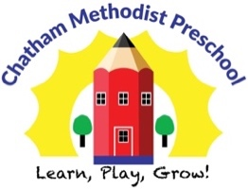

Child’s Name __________________________________________________

Home Address_________________________________________________
Medical/Emergency Release Information

Home Phone ____________________________________________________________________________________

Guardian’s Name _____________________________ Cell # ___________________ Work # _____________________

Guardian’s Name _____________________________ Cell # ___________________ Work # _____________________

Emergency Contact ______________________________________ Cell # ____________________________________

Address___________________________________________________________________________________

Emergency Contact ______________________________________ Cell # ____________________________________

Address___________________________________________________________________________________

Physician’s Name_____________________________________ Phone # _____________________________________

Address __________________________________________________________________________________

Hospital Preferred _______________________________________________________________________________

Address __________________________________________________________________________________

In the event that an emergency occurs, I authorize Chatham Methodist Preschool to seek medical care for my child, _______________________________________, as deemed necessary by the Director and/or teacher in charge. I understand that the school will notify me as soon as possible.

Signature________________________________________ Date ___________________________________

